
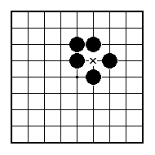
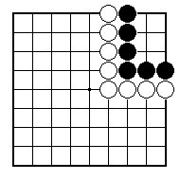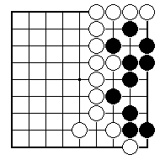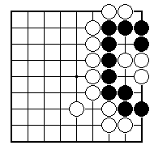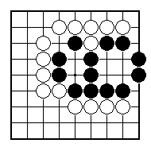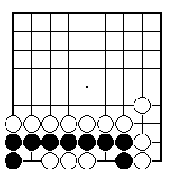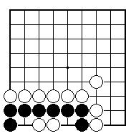
White to play and kill the black group (without starting a ko).

White to play and kill the black group.

White to play and kill the black group.

White to play and kill the black group.

Is the black group alive, dead or what?

Is the black group alive, dead or what?

NAME:
BRITISH GO ASSOCIATION CERTIFICATE LEVEL 2 - SHEET 11

LIVING AND DEAD GROUPS (PART 2)

